USER INTERFACE DESIGN EXPERIMENT-3
Difference between CLI(Command line interface) and GUI(Graphical user interface) and VUI(voice user interface)
Command line Interface(CLI)
● A Text-based Interface (Command line interface) enables users to communicate with a computer using the command line, as opposed to using a graphical interface.
● Compact and Powerful – CLI is usually faster and more powerful than a GUI, particularly for expert users who know the correct commands.
● Automation & Scripting – The command-line interface is there to allow users to automate tasks with scripts, making the repetitive tasks easier.
● Lightweight and Resource Friendly – Compared to GUI application, CLI uses very little system resources which is why they are most suited for use on remote servers
example: Windows command prompt.
IMPLEMENTATION
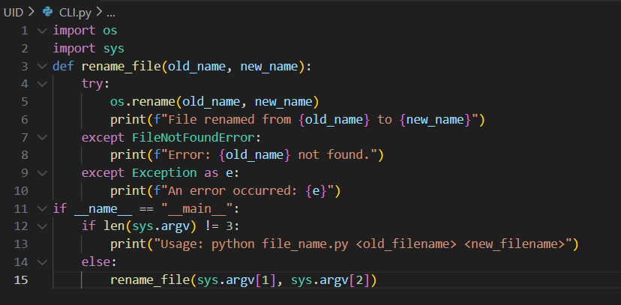

Output
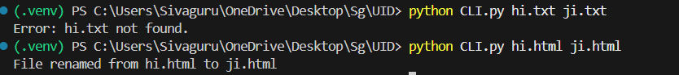Graphical user interface(GUI)
● A GUI uses visual elements including icons, buttons, and windows which makes it more user-friendly for users to work with the system.
● More Resource Intensive – GUI applications use more system resources (CPU, RAM, and GPU) in contrast to a Command Line Interface (CLI) that can degrade performance in low-end devices.
● Limited Automation: GUI does not have automation and scripting abilities like the CLI and is thus more tedious for repetitive jobs.
Example: Windows, Android, iOS
IMPLEMENTATION
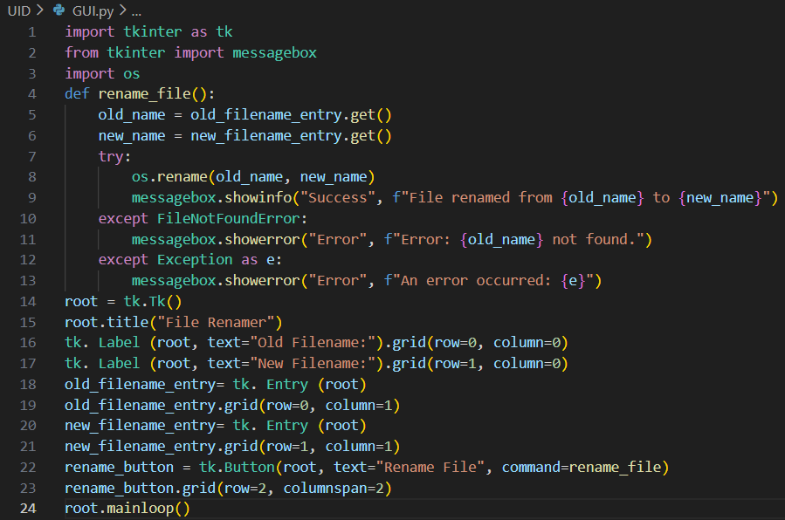

Output

Voice user interface(VUI)
• No Hands – VUI allows me to talk to a system and in some cases this is much more convenient than having to type. • Natural Communication– VUI allows for more natural and fluid communication, as it can process users’ speech and verbal commands, eliminating typing or clicking.
• Accuracy Challenges – Speech recognition can occasionally have difficulty with accents, background noise, and complex commands, sometimes resulting in misinterpretation.
Example: Amazon, Alexa, Google Assistant
IMPLEMENTATION
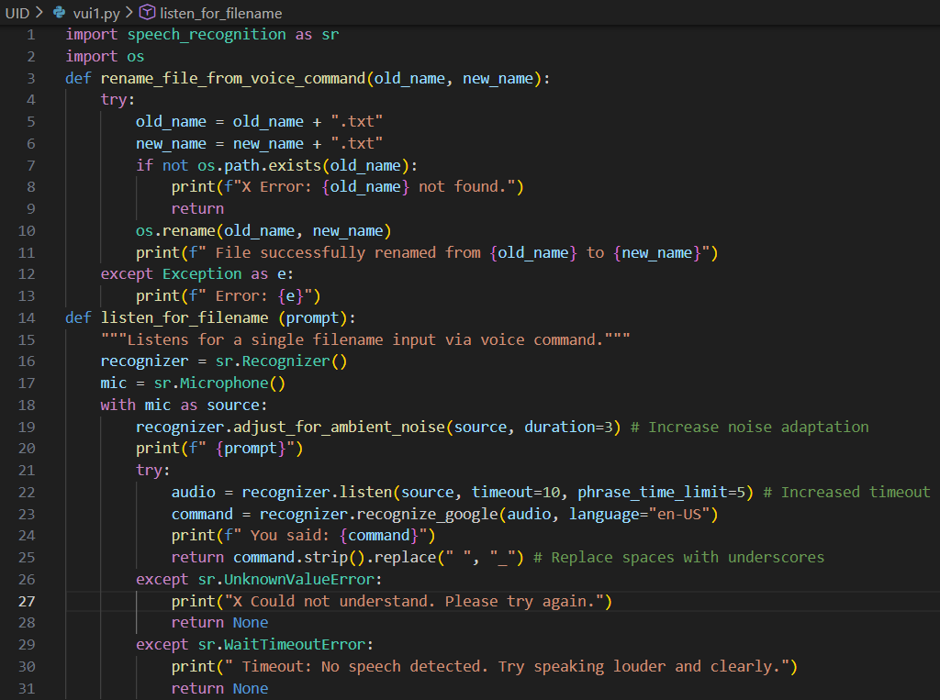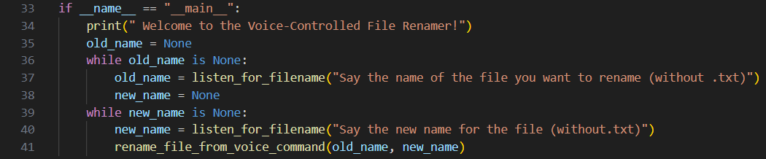Output
